Week 4 Tutorial– Create A Resume Page
Goal of the week: Every student will create a professional one-page resume on their e-portfolio.
Step 0: Before we start today’s project, let’s trim down your website first.
Navigate to your project folder on your computer:
🤖 Prompt to AI
Simplify this project into a basic static website using only HTML, CSS, and Vanilla JavaScript. Keep the existing Supabase integration unchanged.
Step 1: Plan your resume
Before asking AI to build your resume page, decide what information you want to include. Your resume should contain at least:
- Summary
- Experience: Work/Internship/Project Experience
- Education: at least 2 entries (program/degree, institution, dates, and a couple of bullet points where appropriate).
- Skills: 5–10 relevant skills

Step 2: Create your resume
In the chat, type a clear request. Use this starter (then make it yours):
If the AI-generated resume already includes Summary, Experience, Education, Skills, you can skip this step.
If one or more sections are missing, revise the prompt below and ask AI to add them.

🤖 Prompt to AI
On the resume page of my website, please add four sections, in this order, each with a clear heading:
Summary: A 2–3 sentence paragraph introducing me professionally.
Experience: 2–3 entries. Each entry shows: job title, company/institution name, time period, and 2–3 bullet points describing my responsibilities or achievements.
Education: 1–2 entries. Each entry should include my degree/major, school name, and time period.
Skills: A list or grid of my skills (languages, tools, etc.).

Step 3: Preview & check
Preview your resume page and read it from top to bottom.
Check:
- Are all four sections included?
- Are the sections clearly separated?
- Is the information easy to scan?
- Does the page look professional?

Step 4: Make it yours
You can ask AI to help you replace the placeholder content with you real information. For example (use this starter and make it your own):

🤖 Prompt to AI
Help me replace the placeholder resume content with my real information.
Summary:
I am a graduate student majoring in digital education at Xi’an Jiaotong – Liverpool University…
Experience:
1) Internship: Instructional Design Intern
Institution: Xi’an Jiaotong – Liverpool University
Time period: June-August 2026
What I did / achieved:
- Designed…
- Conducted…
2) Another internship or full-time/part-time job if you have one
Education:
1) Master Degree: Digital Education
School: Xi’an Jiaotong – Liverpool University
Time period: 2026-2028
2) Bachelor Degree: […]
School: […]
Time period: […]
Skills:
- Languages: [...]
- Tools/technologies: [...]
- Soft skills (optional): [...]

⚠️ Important: Check every piece of information carefully. AI may generate information that you did not provide. Do not include anything that is inaccurate or made up.

Step 5: Test and refine it (one change per request)
If something does not work (e.g., the “Download resume” button does nothing), don’t ask AI to “fix everything.” Instead, describe one specific problem. For example:
Generate a clean PDF of my resume page (hide nav, footer, and buttons), add it to the project as resume.pdf, and make the Download button download it directly instead of opening the print dialog. Don't change anything else.
- Make the resume look more professional while keeping the current content.
- Make the Skills section more visually appealing.
- Make the Experience section easier to scan.
- …
Step 6: Ship it
Deploy/update the files on Github.
6.1 Go to your Github e-portfolio repository main page (as shown below) and click on Add File, select “Upload files”.
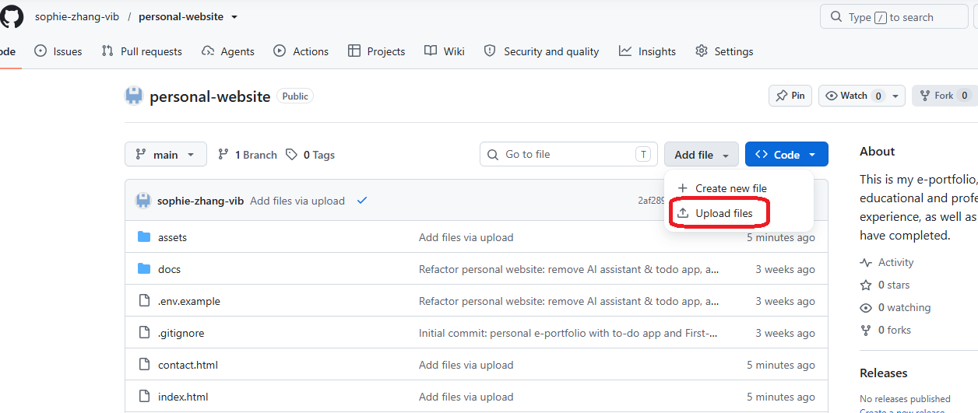
6.2 Then you will land on Drag Files page
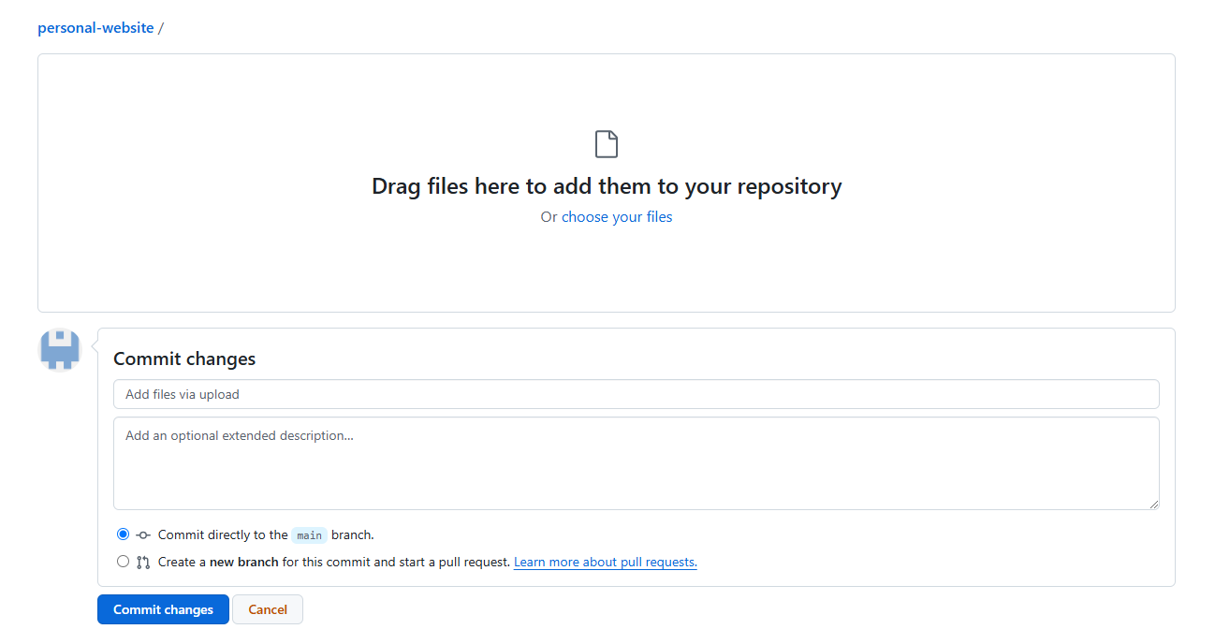
6.3 Drag all html files, assets folder and relevant folders/files from your computer to your Github e-portfolio repository.
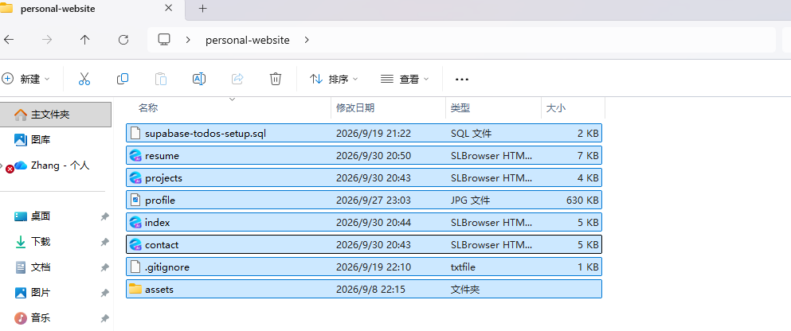
6.4 Once all documents were uploaded, click on “Commit changes” at the bottom of the page.
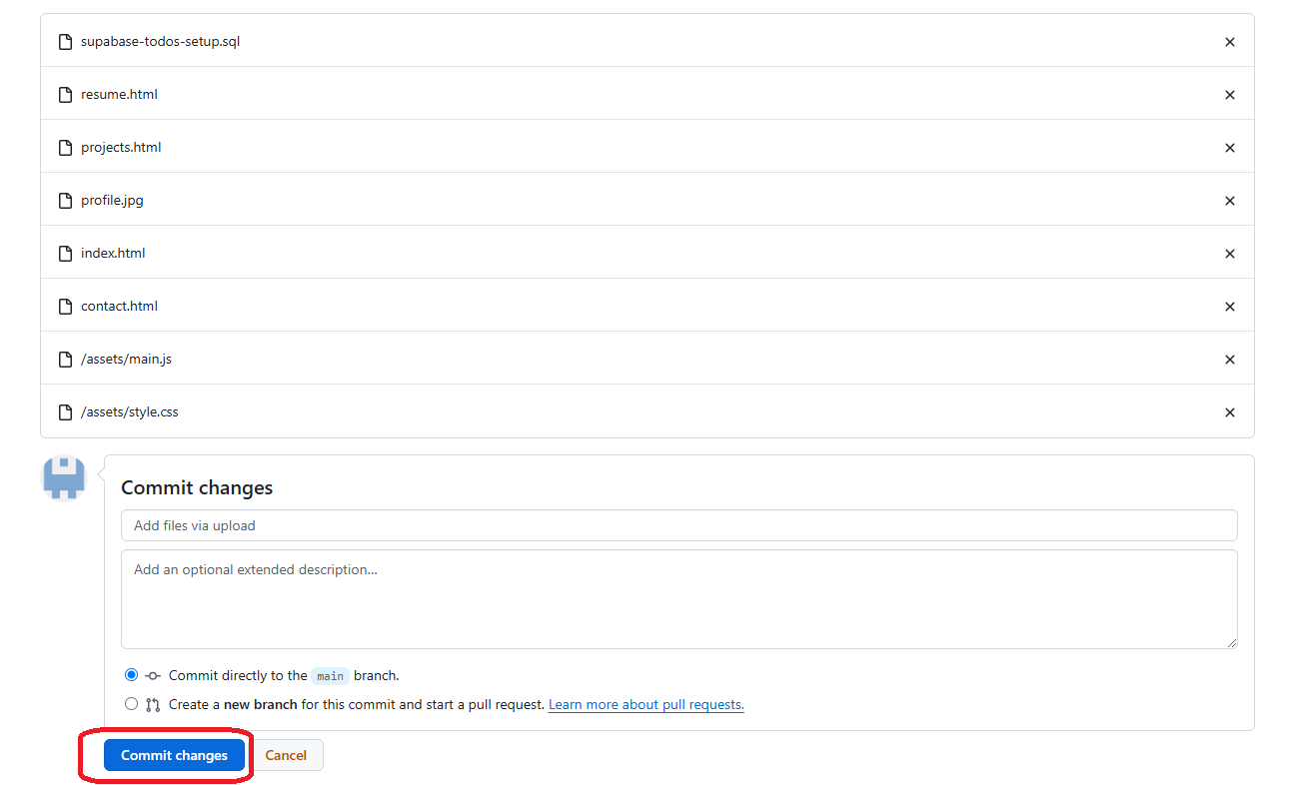
6.5 SettingsPages, wait for a few minutes until the content is updated on your site, then you can visit your site to check out the updates.
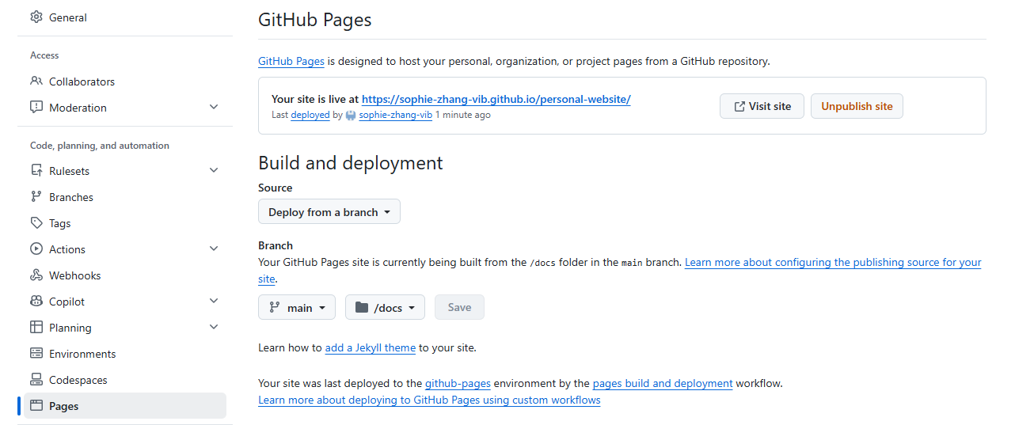

Stretch challenges
- Add a “Download Resume” button (so people can download it as a pdf file).
- Add a sticky header with your name that stays visible as visitors scroll.
- Improve Accessibility - Check color contrast, heading hierarchy, image alternative text, keyboard navigation, and link labels. Ask AI to identify accessibility issues and help you fix them.
Assignment
Submit the following items on Learning Mall Core:
1. The live link to your resume page or a screen capture/photo of your resume page
2. Export the conversation with AI.
2.1 Switch to SOLO IDE on top left corner
2.2 Click on “Export Conversation” on top right corner and save it a markdown document (.md).
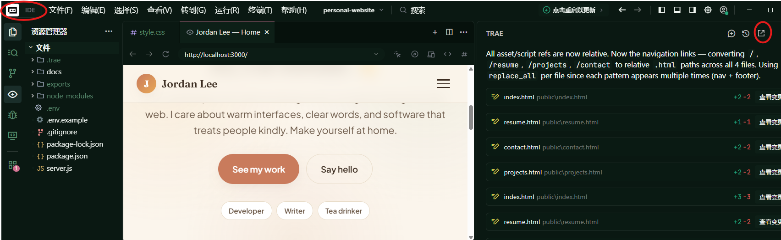
3. Reflection: What are your takeaways, e.g. what did you learn or enjoy the most? What did the AI get wrong or build differently than you expected? How did you fix it?
Due: by the end of this tutorial

Grading Criteria
- Works & is live (20%)
- Meets the brief: the content on the resume is (40%)
- Reflection (40%)

